Winter Happy New Year !

Southern District Newsletter December 2017/January 2018

Here’s hoping that 2017 has been a positive year for all of you in the Southern District. We have had some struggles in some areas, but it looks to me like everyone is moving forward with activities in their respective hospital organizations.

Calendar For 2018

Advocacy Day March 21, 2018 - Madison

Southern District Meeting April 12, 2018 – Beaver Dam

State Convention October 2 - 4, 2018 – Stevens Point

News from our District

It is with regret that we inform you that Jan Sheppard has resigned her position as District Public Policy Chair, and with the loss of our beloved Mary Licht, we also have need of someone to assume the position of Community Health Chair.

PPE Report (Public Policy)
Keep your eyes on the Partners of WHA website for the most current news notes from the state PPE chair. If you are a member of HEAT, you should be getting email messages concerning legislative actions which you could share with your membership and come up with ideas for your response.

CHE Report (Community Health)
Again, keep your eyes on the Partners of WHA website for up to date information from the state CHE chair. The big push everywhere is the opioid crisis in Wisconsin and all across the country.
You can check with the state CHE chair to find program ideas for your community, and ways that you may work toward helping find some workable solutions to this devastating problem.

Year-end reports – Please email copies of your year-end reports (President, PPE and CHE)
to Judy Jaggard - (judy.jaggard@gmail.com) or mail them to Judy Jaggard, at 1510 Excalibur Drive, Janesville, WI, 53546, before the end of January, 2018. (I prefer sooner rather than later in January!) Remember that I only need one copy of each report, not three. I will take care of sending everything to the state officers.

Some fun pictures from our district meetings:
Stoughton – March 30, 2017

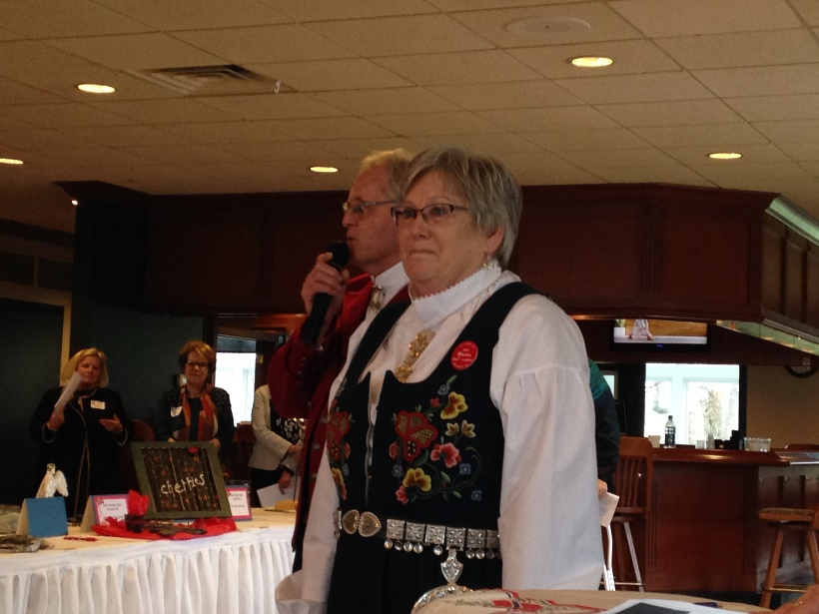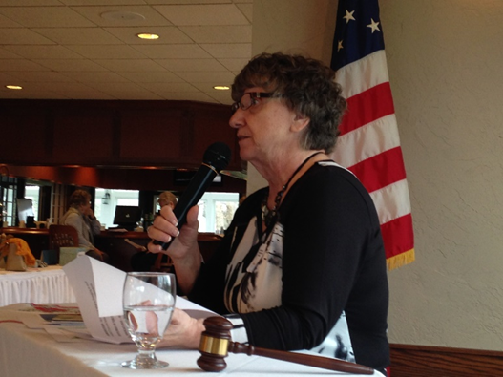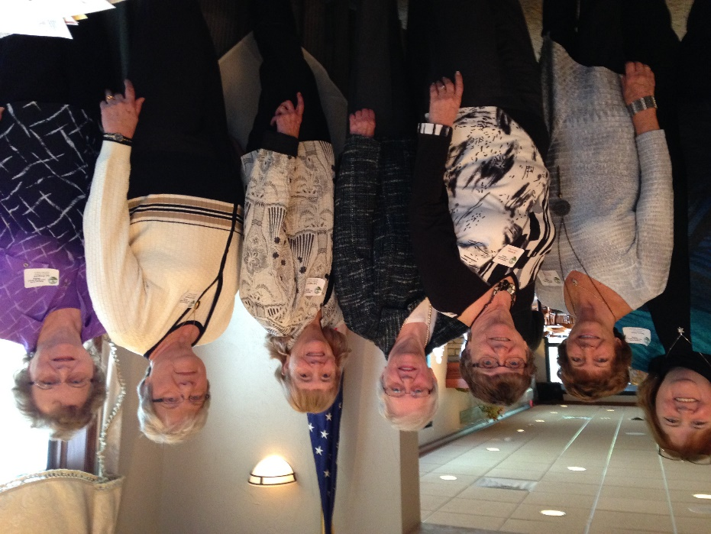
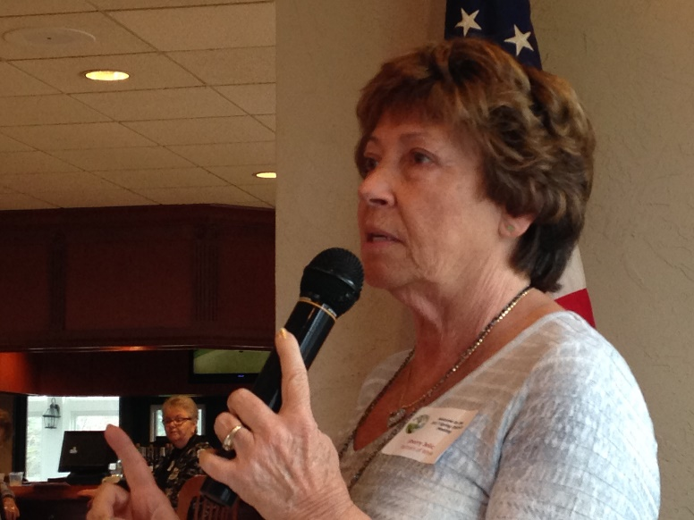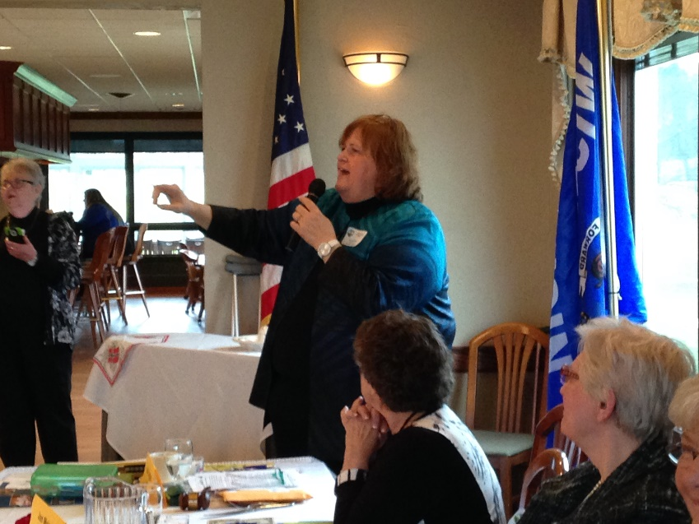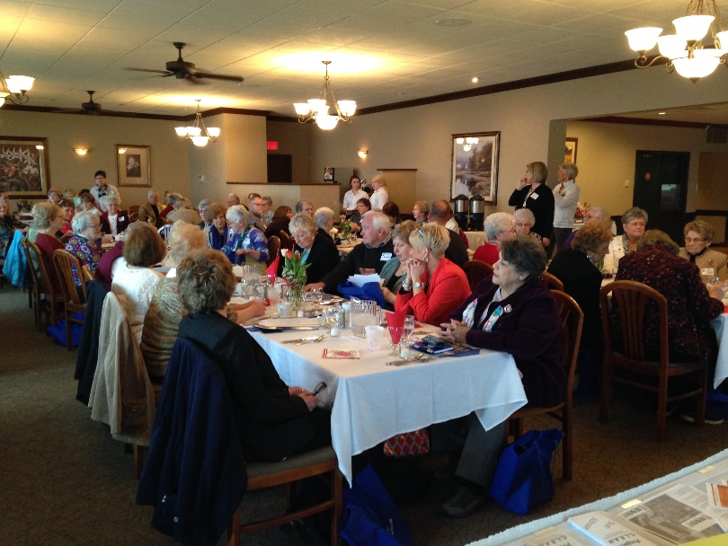

Baraboo – September 21, 2017
