**Volunteer - Partners**

**Ascension Eagle River Hospital**

**Newsletter** *July, 2019*

The Volunteer - Partners of Ascension Eagle River Hospital gave four $1,000 scholarships to four students from Northland Pines High School.  The students were chosen from numerous applications from Northland Pines High School, Phelps High School and Three Lakes High School.

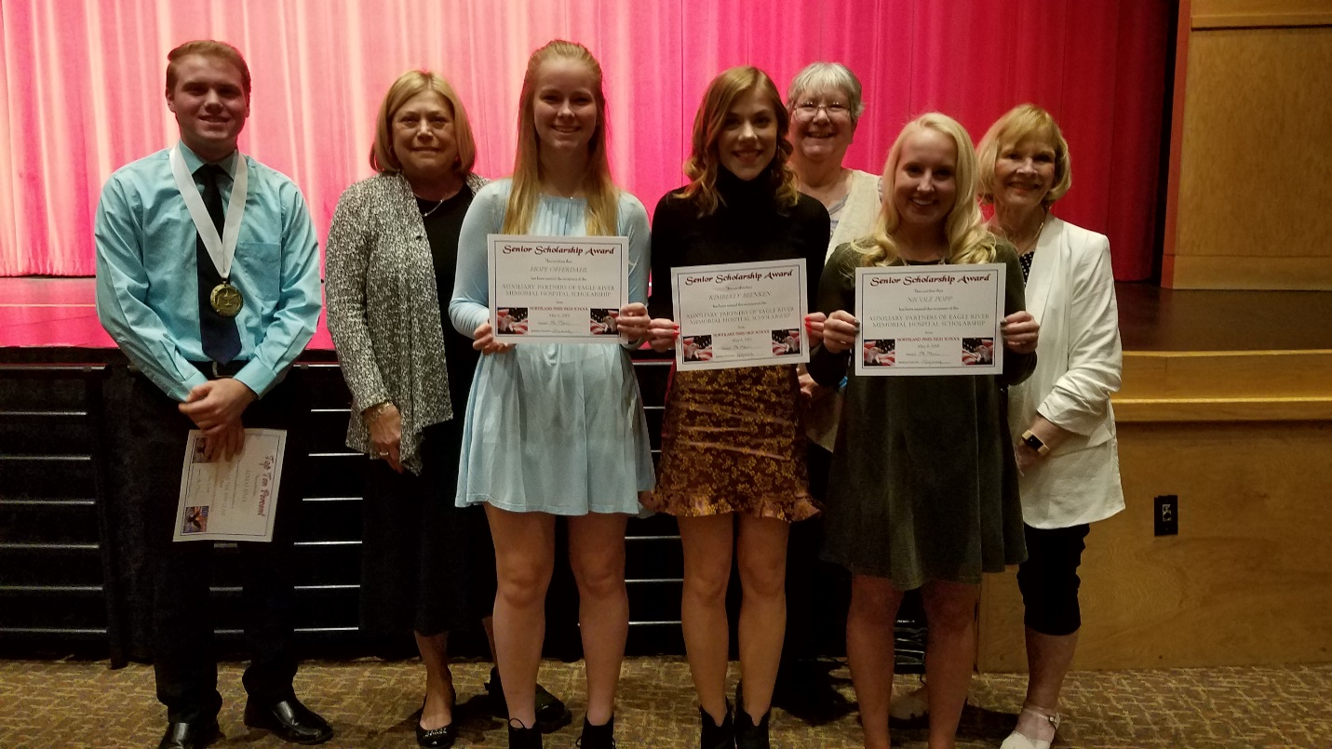

From left to right: *Adam Sima, Diana Sell, Hope Offerdahl, Kimberly Beenken, Pam Cira, Nicole Popp, and Teri Kressin*

* Adam Sima was a scholarship winner and will be attending the University of Minnesota in pre-med. He is aspiring to become a Neurosurgeon.
* Nicole Popp was accepted to the University of Wisconsin - Lacrosse.  She will pursue a degree in Physical Therapy.
* Hope Offerdahl was accepted to the University of Wisconsin - Madison in the field of Mental Health. She hopes to become a psychiatrist.
* Kimberly Beenken has been accepted to Nicolet College.  She is pursuing a career as a Veterinarian.

These students excelled both academically in school and in their service to community. The Volunteer - Partners of Ascension Eagle River Hospital awards four $1,000 scholarships to high school students who plan to pursue degrees in the medical field each year. It also awards two $1,000 scholarships to hospital personnel who wish to further their career in a medical field. *Congratulations students!*

**Volunteer Recognition Luncheon - Held at Eagle River Inn**

An annual celebration of volunteer hours and years of service was held at the Eagle River Inn – Chef Renee’s mid-June. Roughly 60 volunteers participated, enjoying conversation, updates on hospital activities and a luncheon with dessert buffet before awards were presented.

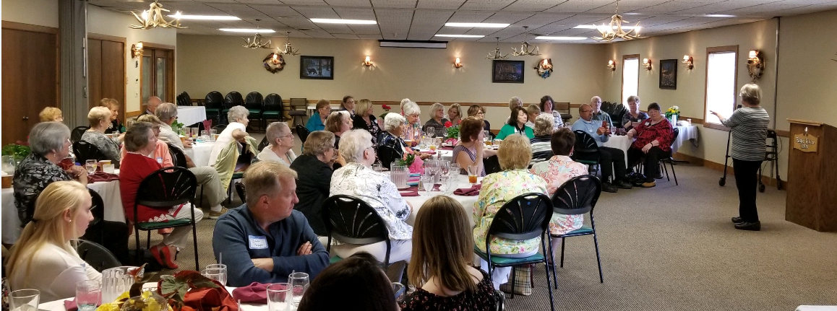

Shirley Spiess

Pam Berdal, Volunteer Coordinator (pictured above) shared her appreciation for all in attendance that give throughout the year in service to the hospital and their community.

Years of service was acknowledged with a specific mention of Shirley Spiess that has proudly volunteered for 55 years (pictured right). In addition, Service pins were distributed to individuals that have individually accumulated up to *19,000 hours*!

Service hours are accumulated through leadership and committee involvement, as well as volunteer time given to the Thrift Shop, Hospital Elder Life Program, and assisting in various areas throughout the hospital.

*“55 Years” of Service*

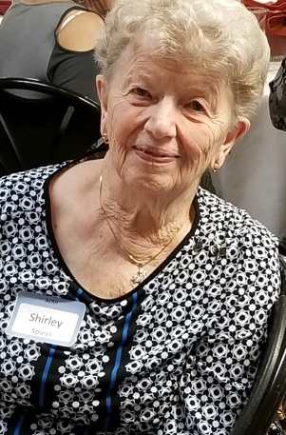

Scholarship Committee pictured with two of the 2019 High School

Scholarship Recipients that joined in the day’s celebration.

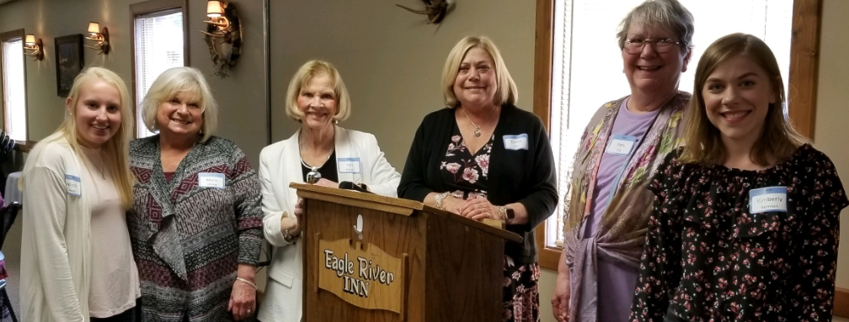

Pictured from L to R: *Nicole Popp, Marie Maciag, Teri Kressin, Diana Sell, Pam Cira & Kimberly Beenken*

**All Smiles…**

**500 Hours** Betty Andrew

Margaret Artus

Margo Granat

Kathleen Greif

Terri Kressin

Suzanne Kubacki

Rosemary Leveille

Karla Lokker

Donna Wilcox

Karen Young

Gene Weber

**1,500 Hours** Pam Cira

Priscilla Ellenberger

Janey Libby

**2,000 Hours** Marie Maciag

**2,500 Hours** Karol Burns

Jan Christofferson

Joan Peterson

Gilbert Wank

**3,000 Hours** Molly Jaeger

**3,500 Hours** Judy McGinnis

**4,500 Hours** Peggie Lambert

**5,000 Hours** Diana Sell

**5,500 Hours** Elizabeth Purtell

Marlys Lee

**6,500 Hours** Bernice Gilbert

Joyce Wied

**7,000 Hours** Dorothy Ivaska

**7,500 Hours** Dorothy Lorch

**8,000 Hours** Ken Holdman

**11,500 Hours** June Ong

**19,000 Hours** Joan Holdman

**Hours of service recognition**

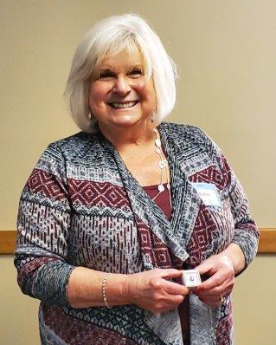

Marie Maciag

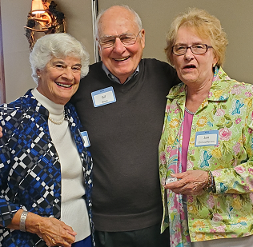

Joan Peterson, Gil Wank

& Jan Christofferson

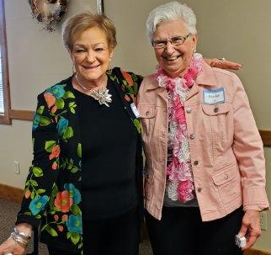

***& In Loving Memory…*****We recognize the Volunteers who passed this year**. Each contributed many hours of service to our organization and **will be** **greatly missed.**

* *Peggy Kalt*
* *Nancy Hadler*
* *Joe Keenan*
* *Dennis Berdal*
* *Jim Slagle*

Elizabeth Purtell & Marlys Lee

## **Advocacy Day 2019 was held on Wednesday, April 17, 2019 ​**According to the Partners Wisconsin Hospital Association website, Wisconsin Hospital Association hosted two governors.  Governor Tommy Thompson had a fireside style talk with Eric Borgerding, CEO of WHA, and Governor Tony Evers spoke at lunch. The legislative panel included four members of the Joint Finance committee.

## Legislative priorities included:

## the importance of hospitals to local economies

## improving reimbursement for Medicaid services

## and removing legal barriers to the practice of telemedicine.

## 

## Roughly 1,000 attendees participated in the event, dedicating time to learn about the public policy issues; 600 of whom met with their legislators to discuss the issues*.  (source: partnersofwha.org)* To find out more about current issues, go to partnersofwha.org or wha.org.

**Save the Date for the WHA Partners - North Central District Fall Conference**

Join volunteers from hospitals across the north central district at this year’s fall conference to be held at **The Waters in Minocqua, Tuesday, September 17th**. Jessica Schiek, Director Ascension Koller Behavioral Health is the guest speaker. The topic will focus on the stigma of mental health disorders and how, we as a community, can help overcome that stigma. **Registration information will be sent at a later date**.

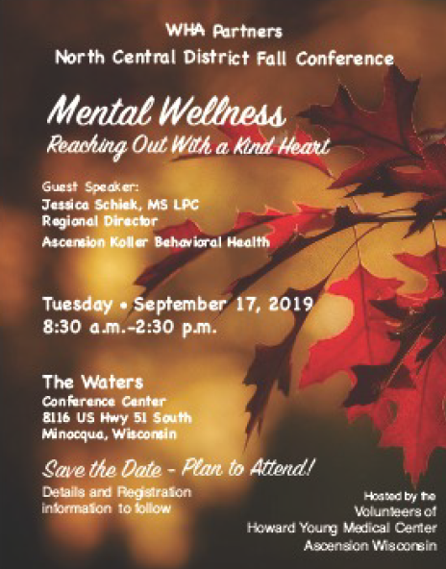

*F-i-t-n-e-s-s Fact*

**Keep active.** [Do something to keep fit](https://www.parentgiving.com/shop/staying-fit-261/c/) - each day something you enjoy that maintains strength, balance and flexibility and promotes cardiovascular health. Physical activity helps you stay at a healthy weight, prevent or control illness, sleep better, reduce stress, avoid falls and look and feel better, too.

**Events & Happenings**

**SAVE THE DATE**

**September 17**

North Central Fall District Meeting – Minocqua

**September 19**

Day of Renewal – Moon Beach – St. Germain

**October 1 – 3**

Partners of WHA State Convention – Red Lion Paper Valley - Appleton

[](https://www.google.com/url?sa=i&rct=j&q=&esrc=s&source=images&cd=&cad=rja&uact=8&ved=2ahUKEwiPkofivfHgAhUi5IMKHWshDa0QjRx6BAgBEAU&url=https://requestreduce.org/image/calendar-clip-art/20318.html&psig=AOvVaw3o6LWsG_9YQmC01pnZH7mk&ust=1552096310095588)

**Your Time & Talent is Needed**

**Thrift Shop** – The Thrift Shop provides a wonderful service to the community by recycling clothing and household goods at affordable prices, with all proceeds from the sales benefiting Ascension Eagle River Hospital. Join an active team and assist with sorting, stocking and/or selling merchandise.

**Hospital Elder Life Program (HELP)** – The Hospital Elder Life Program is a meaningful service provided to improve the hospital experience of older patients. Volunteer role includes:

* Daily visits designed to keep patients alert and aware by providing orienting communication and daily schedule as well as answering questions.
* Provide company and assistance with meals, encouraging oral intake to enhance nutrition and hydration.
* Initiate activities to keep minds active and relieve stress.

**Out Patient Therapy** – Ascension Eagle River Hospital’s direct patient care and support departments value the work of their volunteers. Each department has a specific set of routine essential tasks that volunteers perform that range from clerical functions, to cleaning practices, to stocking supplies and a variety of other activities specific to the department’s needs and the volunteer’s ability. Volunteers are an integral part of the team!

**Front Desk** – Offer a friendly presence by greeting all patients, visitors and staff entering and existing the main entrances of the hospital. Brighten a patient’s day when having the opportunity to deliver flowers sent by family or friends, provide helpful directions to those in need of finding their way, share brief conversation or ensure reading material is available to those in the entrance waiting area. All make a meaningful difference to creating a welcoming, supportive environment.

Interest? Contact Pam Berdal, Volunteer Services Coordinator 715-479-0327

**Celebrating *YOUR* Day…**

[](https://www.google.com/url?sa=i&rct=j&q=&esrc=s&source=images&cd=&cad=rja&uact=8&ved=2ahUKEwishsGywfHgAhVB4IMKHed0CDkQjRx6BAgBEAU&url=https://www.holidaycardsapp.com/cards/rainbow_birthday_cake_card&psig=AOvVaw0t4HVJeTDrjGmaGARUMfso&ust=1552098923750625)

**July Birthdays**

Bonne Berta - 02

Karol Burns - 16

Evette Danielak- 21

Priscilla Ellenberger - 28

Bill Green - 27

Dorothy Ivaska - 06

Barb LeMoine - 02

David Liedtke - 03

Rosemary Leveille - 25

Jean Neumann - 03

Ruth Steinke - 09

Peggy Waldron - 29

Karen Young - 17

**August Birthdays**

**…wishing *YOU* joy!!**

Suzanne Kubacki - 11

Susan Kurth - 17

Peggie Lambert - 06

**New Volunteer Highlight**

Welcome, Sonja Graves

Volunteering in Physical Therapy

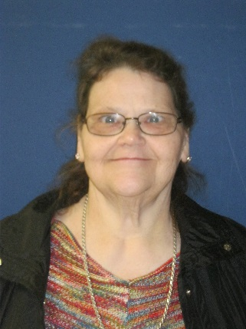

Daniel Majewski - 19

Carol Pekarek - 01

Joan Peterson - 14

Mary West - 19

**September Birthdays**

Betty Andrew - 17

Nancy Diepenbrock - 26

Dawn Guzman - 25

Marie Maciag - 16

Lisa Pepp - 15

Marilyn Preisler - 02

Marilyn Schneider - 07

Pat Van Acker - 21

Gene Weber - 12

***“Volunteers offer the fullness of who they are by giving of their time & talents to others in need.”***

[](https://www.google.com/url?sa=i&rct=j&q=&esrc=s&source=images&cd=&ved=2ahUKEwiOuM3fh67jAhUDHM0KHQo1BT0QjRx6BAgBEAU&url=https://gallery.yopriceville.com/Free-Clipart-Pictures/Balloons-PNG/Balloons_Transparent_PNG_Clip_Art_Image&psig=AOvVaw2iCW-a6Wpa6UAFoiX7MJG6&ust=1562975536992661)