Northwestern District

Fall 2018 Newsletter

***Message from the Northwestern District*** *Chair*

**Ginny Bosse – Flambeau Hospital Auxiliary, Park Falls** The Northwestern District fall meeting will be held before fall officially arrives, on Tuesday, September 4th at St. Mary’s Hospital-Superior. If your Partner group hasn’t RSVP’d yet, please do so ASAP! Remember that having at least two people from your group in attendance at district meetings helps earn Honor Points. On the agenda, in addition to our regular NW District business, will be scheduling our volunteer guides for the Partners Convention. (The job of the Hospitality Committee is to help attendees find where they need to go. The extremely compact convention hall will make our job very easy!) The Partners of WHA 2018 state convention will be held Tuesday at 1:00 PM through Thursday noon, October 2nd-4th at the Holiday Inn and Convention Center in Stevens Point. The registration deadline is Friday, September 7th. *Be sure to use the corrected mailing address that you received recently and separately from the full brochure via USPS mail!* The deadline for reservations at the hotel is the 13th of September, and any remaining rooms will be released on the 14th, which means the price will go up. As always, at convention, there will be informative and inspirational speakers and workshops. I hope each of our Northwestern District groups is sending some of its members! Remember that your group receives 5 Honor Points for each of the two voting delegates every group is allowed, two for setting up a display, and two for contributing an item to the Silent Auction. Honor Point Awards for 2017 will be given out at the convention. *It is very important that each of our groups designate their two voting delegates! During the Annual meeting, the proposed Bylaws will be voted on and the election of a President-Elect, Secretary and Treasurer will be held, and only delegates will be voting!* If you didn’t attend the Spring Tour NW District meeting and missed the comparison of the proposed bylaws and current bylaws PowerPoint presentation, I hope you will download it from the Partners website and use it as you go through the proposed bylaws. It took me a lot of time to create the PP, and it truly can help you get to know the proposed Bylaws and how they compare to the current ones. All three documents are available on the Partners website. The Bylaws Committee spent nearly a year on the proposed Bylaws and received input from an attorney that has done work for WHA. I sincerely hope that they will pass as presented, because they rectify sections that are contradictory in the current bylaws! *If you still have questions, submit them when registering for the Bylaws conference call which will be at 10:00 AM on Thursday, September 21st.*

The Nominating Committee has nominated Peg Larson, who is currently finishing her second term as Partners Treasurer, for President, Sharon Scott, who currently Co-Chair of the 2018 Convention Committee and will Chair the 2019 Convention Committee, for Secretary, and Julie Steiner, currently president of the Friends of Vernon Healthcare and a member of the WAVE Committee, for Treasurer. Nominations from the floor are allowed and will likely be made. I personally endorse each of the excellent candidates the Committee has put forth.

***Northwestern District Leadership Meeting* Ginny Bosse – Flambeau Hospital Auxiliary, Park Falls**

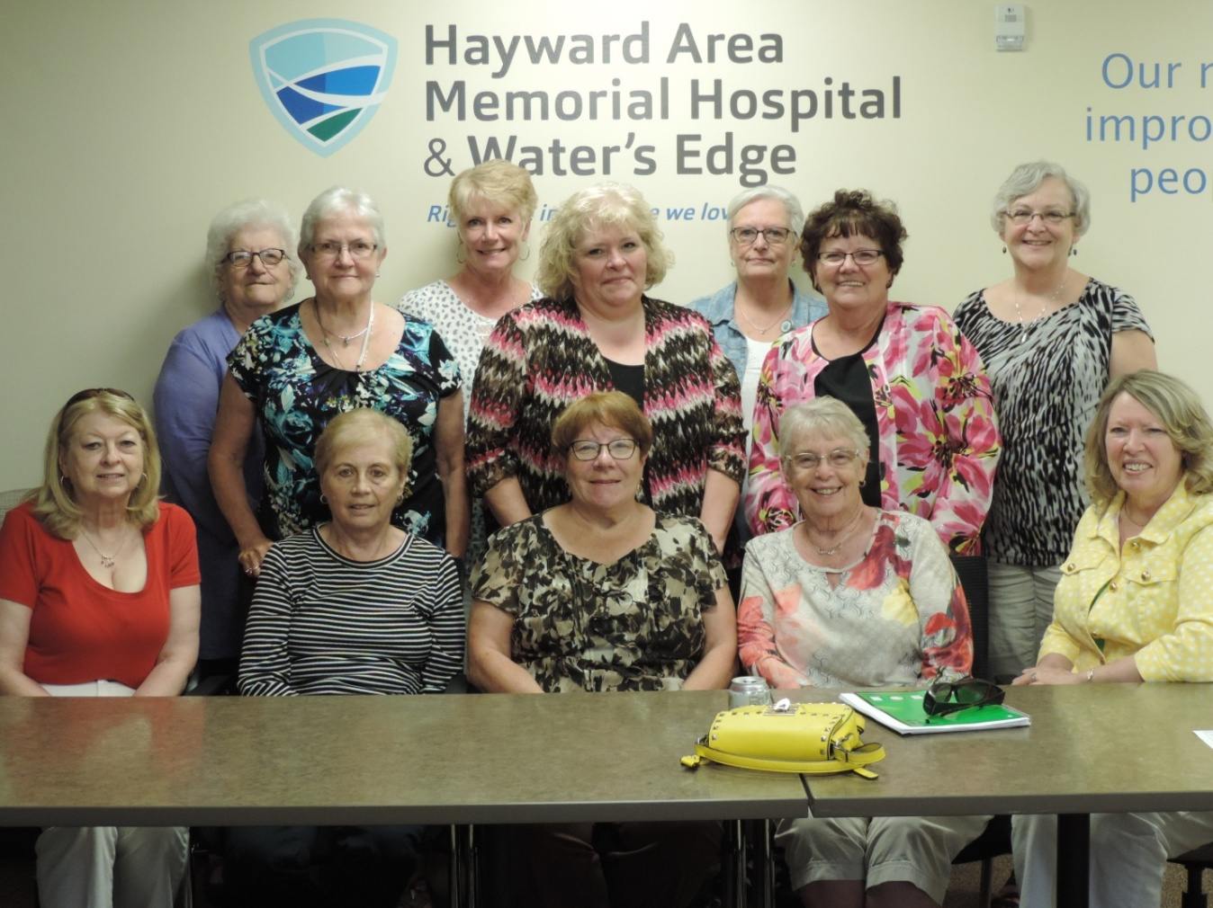

On Tuesday, July 17th, a dozen members from five of the seven groups in our NW District met at Hayward Memorial Hospital. Because our Board of Directors in Park Falls has fourteen members, and we are considering lowering that number, changing the makeup, terms, etc., I was curious about membership categories and dues of each organization, as well as the size and structure of the other Partner groups’ Boards, including which officers are elected, what their terms are, whether they are all elected at the same time, term limits, etc. I created a frame for note-taking, with a row for each of our Partner groups and columns for each of those areas, and after a round of self-introductions, that is how we started our day. (When you become NW District Chair, you will get to set agendas, too!☺) Like last year’s Leadership Meeting, it was a wonderful day of conversation and getting to know each other and each others’ organizations. The Volunteers are People – Leadership Information, an overview piece on Robert’s Rules of Order, and an inspiring list of Volunteer Quotes, were handed out again this year. Some of the materials I had received from my mentor last year – yes, Partners of WHA has started a mentoring program for new District Chairs!

Here are a few of the quotes: “Great opportunities to help others seldom come, but small ones surround us every day.” (Unknown) “Volunteers are paid in six figures: S-M-I-L-E-S” (Gayla Le Marie) “The world is hugged by the faithful arms of volunteers.” (Terri Guillemets)

***Message from the Northwestern District PPE Chair* We currently have no one in this position! A reminder from Ginny to vote and advocate:**

The Wisconsin Primary Election held on August 14th was a partisan primary that decided who from the various political parties will be on the ballot in November. I hope you will consider not just the party affiliation, but what the candidate stands for regarding our hospitals and healthcare, as well as other issues that you truly care about. (For me, a 37-year first grade teacher in the public school system, one of the biggest is adequately funding public education, which is the foundation of democracy!) So, please do your research and cast your ballot on Tuesday, November 6th! It is also crucial to stay abreast of pending legislation regarding healthcare and other important issues. A good way to be kept aware of what is going on in healthcare is subscribing to WHA’s weekly email newsletter *The Valued Voice* and sign up for Hospitals Education & Advocacy Team (HEAT) email alerts. Both can be done on the Wisconsin Hospital Association website wha.org.

***Message from the CHE Chair*  Beth Burnham – President, Volunteer Partners of Spooner Health**

Hi everyone, this is my first report as the new District Community Health Chair. As we are winding down our health topic for these last two years I would like to take a look back at what has happened in regards to this important issue. We have heard on the news and read about all of the horrible statistics about the overdose deaths and the increasing addiction rates not only in the nation but also in our own communities. I would like to talk about some positive things that are happening in the last two years. Doctors are scaling back the number of scripts written for narcotics and patients are being asked to sign pain contracts that make them more aware of their use of these drugs. The pendulum is finally swinging back to a more common sense approach to pain management, treating the whole person and not just the pain. There are pain clinics where people can be assessed for their symptoms and work to find other options for pain management. A person with chronic pain really needs solutions to cope with their pain as it is very debilitating and affects their quality of life. There are many modalities that help with pain relief such as massage therapy, meditation, even acupuncture. It is unrealistic to expect that you can ever be completely pain free, and by trying to achieve that end pain meds were overprescribed and abuse would soon follow. PBS ran an excellent program about two months ago where they covered all aspects of the opioid crisis, and I would like to pass along a Quote from one of the doctors about this. Dr. Richard Blondell,  from the National Center for Physician Training on Addiction, said that education is the key, educating our children, our doctors, our parents, our public health officials and our politicians working together to effect a strategy of prevention. It took some time to get where we are, and it will take time to make significant changes but we must do it because so many lives depend on it. After our Convention we will have a new health topic to focus on so until then have a great rest of the summer. Beth

***News from around the Northwestern District***  **Beth Burnham – President, Volunteer Partners of Spooner Health** Here are the latest updates on what we have been up to since the last newsletter in April. We awarded three scholarships to students going into health related fields. The total amount with matching funds from the hospital was $6,000. Our Volunteer Appreciation Luncheon was very well attended with great food and fellowship. Also in April we hosted the Spring Tour District Meeting. There was a terrific turnout by Partners groups. Our speaker was Bridget Rongner, the Director of Faith in Action of Washburn County. She shared the many services provided by them, and it was very interesting. Of course we had a tasty lunch provided by the ladies of Trinity Lutheran Women’s Group, and no one left hungry. Our Greeter/Escort Program continues to do well, and the Gift Shop is very successful with the support of hospital and clinic employees as well as the community. We have had some special sales and will hold our **Holiday Open House Nov. 15th and 16th**. This July we provided tickets to the rodeo for 12 Maple Ridge Nursing Home residents, and a good time was had by all. Our July Potluck was held at the Potters Shed in Shell Lake. Despite the rain, it was a fun evening. Some of our members painted pottery which got fired in the kiln and they were able to take it home with them. Some of our other activities included an information booth at our hospital’s Health Fair, where I had brochures and also some info on Pain medicines. We just held our Pie and Ice Cream Social, great for these hot days. Going forward we will have another bake sale as well as the used book sale. We also were a sponsor for the Annual Golf Outing which raises funds for various hospital projects. Four of our members will participate, and they usually do well. That is all for now. It has been a busy summer and of course October will be busy as well. **Our Fall Thrift Store Fashion Show is Oct. 13th at the Trinity Lutheran Church in Spooner. Come join us!!**

**Ginny Bosse – President, Flambeau Hospital Auxiliary, Park Falls** Our FHA spring events were very successful: Mini Medic Days, the Babysitting Clinic, and the Salad Luncheon. One hundred thirty-seven Salad Luncheon tickets were sold, and after adding in the monetary donations and subtracting the expenses, the Salad Luncheon again netted FHA over $1000, enough for one of our scholarships! The Volunteer Recognition Luncheon was very nice. As always, we were treated to a wonderful lunch and received a small gift, which this year was an insulated Flambeau Hospital lunch bag and $5 in $1 certificates to the every-Wednesday Farmers Market. Shortly after the application deadline of July 15th had passed, *five $1000 scholarships were awarded*: one to a future speech and language pathologist, one to a future occupational therapist, one to a future neuropsychologist, one to a December 2018 graduate who will be a Registered Nurse after passing the National Council of State Boards of Nursing Exam (NCLEX), and one who is on the pre-professional track to becoming a physician assistant.

**NORTHWESTERN DISTRICT OFFICERS 2018-2020**

CHAIR CHAIR-ELECT

Ginny Bosse Vacant

1360 Boettcher Ave

Park Falls, WI 54552

(715)762-3193

[**gbosse@live.com**](mailto:gbosse@live.com)

SECRETARY/ TREASURER CHE

Linda Fish Beth Burnham

1205 11th Ave. W. N2579 Willow Trail

Ashland, WI 54806 Shell Lake, WI 54871

(715)292-6566 (715)468-2524

[rolnfish@charter.net](mailto:rolnfish@charter.net) betheburnham@hotmail.com

PPE

Vacant

**LOCAL PRESIDENTS**

ASHLAND HAYWARD (Co-Presidents)

Linda Fish Pam McClelland Carol Knudson

1205 11th Ave W 15068 W. Nelson Lake Rd 11860 N Eytchenson Rd

Ashland, WI 54806 Hayward, WI 54843 Hayward, WI 54843

715-292-6566 (H) 715-634-3952 715-634-8084

715-209-3881 (C) macinhayward@gmail.com [**cknudson**](mailto:cknudson@centurytel.net)**46@gmail.com**

rolnfish@charter.net Term expires 1/2019

Term expires 1 /2019

LADYSMITH PARK FALLS SHELL LAKE

Beverly Lazar Ginny Bosse Linda King

W411 Southfork Rd. 1360 Boetcher Ave W6265 Pair O Lakes Rd

Hawkins, WI 54530 Park Falls, WI 54552 Trego, WI 54888

715- 492-6572 715-762-3193 715-635-6507 -

lazar_beverly@yahoo.com gbosse@live.com ljkwhitetailridge@gmail.com

Term expires 1/2019 Term Expires 1/2019 Term expires 11/2018

SPOONER SUPERIOR

Beth Burnham Patti Francisco

N2579 Willow Trail 4285 E. Booker Rd.

Shell Lake, WI 54871 Superior, WI 54880

715-468-2524 715-394-4470(H) 218-591-7494(C) bethburnham@hotmail.com [patty.francisco@essentiahealth.org](mailto:patty.francisco@essentiahealth.org) Term expires 12/31/19 Term expires 6/30/19