artners
P
of Wisconsin Hospital Association, Inc.

24th Annual Partners of WHA, Inc.
Wisconsin Awards for Volunteer Excellence

2026 WAVE

Award Application

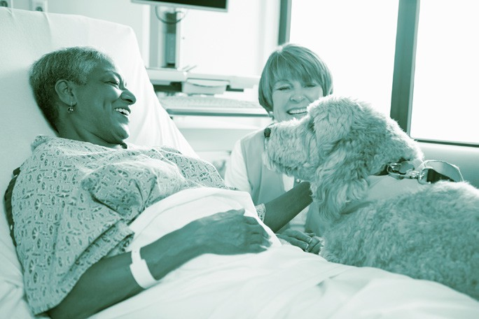
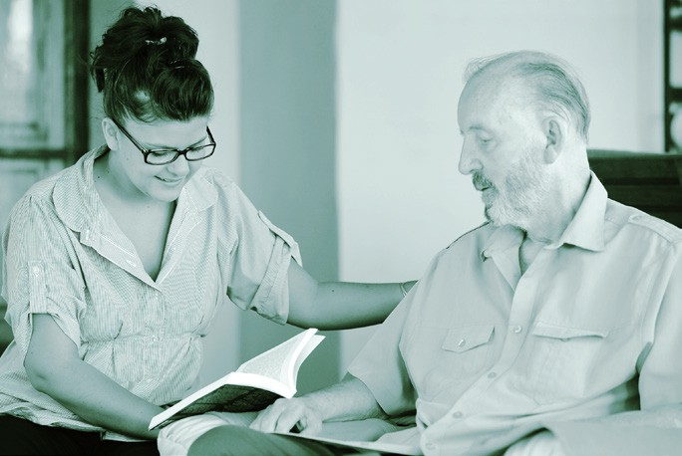
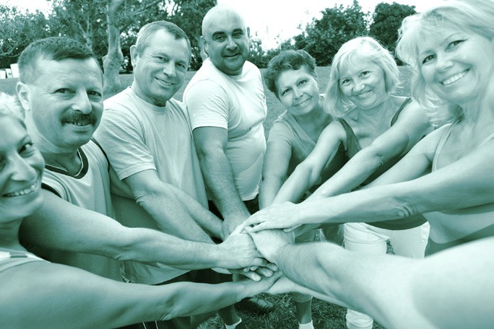
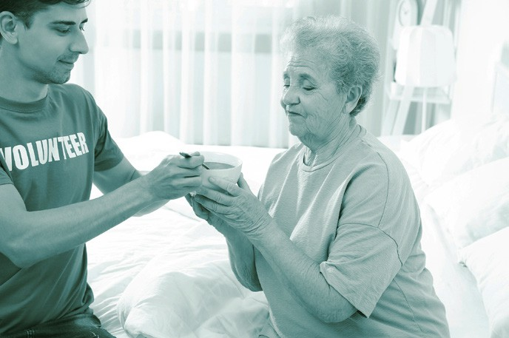
The Wisconsin Awards for Volunteer Excellence (WAVE) program was established by Partners of WHA, Inc. to recognize outstanding contributions of organized volunteer programs.
Applications must be postmarked by July 13, 2026

About the WAVE Awards

Award Categories
One WAVE Award may be given to a program in each of the five categories:
- Community Service
- Fundraising
- In-Service
- Community Outreach and/or Collaboration
- Public Policy and Advocacy

Eligibility Requirements
The WAVE Award recognizes volunteer programs whose work directly furthers the mission of the institution they serve. To be eligible for an award, volunteer programs must:
- Be affiliated with a Partners of WHA member organization in good standing.
- Have demonstrated to have made a significant contribution to the organization.
- Currently be maintained by members of Partners of WHA.
- Be submitted by a member of Partners of WHA.
- Guarantee volunteer representatives be present at the Partners of WHA Annual Convention to receive the award, if selected.

Nomination Process
- Only ONE nomination may be submitted per year by each eligible Partners of WHA member.
- Permission of the hospital/health system’s CEO must be obtained prior to nomination submission.
- Responses to each application question must be limited to 200 words maximum.
- No supporting documentation is allowed. However, links to websites as reference are allowed.
- All nominations for the 2026 WAVE Awards must be received by WHA by July 13, 2026.

Final Submission of Nomination
Final nomination can either be mailed or emailed.
Mail: Wisconsin Hospital Association
Attn: Partners of WHA WAVE Award 5510 Research Park Drive, Suite 200
Fitchburg, WI 53711
Email: education@wha.org

All nominations for the 2026 WAVE Awards must be received by WHA by July 13, 2026.

Selection Process
A Partners of WHA review committee will select no more than one program in each of the five WAVE categories. Decisions of the WAVE review committee are final.

Notification of Results
Representatives (Partners of WHA member who submitted the nomination and associated hospital/health system CEO) of award-winning programs will be notified by both telephone and letter by the end of August. Regrets will be emailed by the end of August.

Presentation of WAVE Awards
Awards will be presented by the WAVE review committee chair at the Partners of WHA Annual Convention October 14, 2026 in La Crosse, WI.

Questions
Contact 2026 WAVE Committee Chair Ginger Arms at ginbud4643@gmail.com.

2026 Wisconsin Award for Volunteer Excellence (WAVE) Nomination Form

Name of Volunteer Program being Submitted for WAVE Award:

Program Category (select only one category)
Community Service: Programs that assisted a health care organization in the design and delivery of services or programs of measurable impact to the wellbeing of individuals and/or the community.
Fundraising: programs that designed and implemented an innovative approach to fundraising that benefited the health care organization or the community.
In-Service: programs that designed and implemented innovative services to address needs or challenges within the health care organization.
Community Outreach and/or Collaboration: programs that designed and implemented an innovative approach with external partners to address needs or challenges within the health care organization or the community.
Public Policy and Advocacy: Programs and activities designed to identify and positively impact health care policies and legislation in our local communities and the state.

Name of Volunteer Organization Submitting the Nomination:

Partners of WHA Member Submitting the Nomination Form
Name Title Phone ( ) Email (required) Name of Hospital/System Mailing Address City State Zip
Partners of WHA District

Chief Executive Officer of Nominated Hospital/System
Name Title Email Phone ( )
Signature
Signature indicates knowledge and support of the nomination of the above stated program for the 2026 WAVE Awards

Application Questions

- Provide a brief description and goals of the program, including the date program was implemented. Describe what organizational or community need it meets. (200 words maximum)

- Describe the role of volunteers in planning, developing, implementing and maintaining the program. (200 words maximum)

- Describe the outcomes of the program. Include quantitative or qualitative measures, such as outcomes data, satisfaction scores, or example of impact. How does this program benefit recipients, the hospital and/or the community? (200 words maximum)

- Describe how the program is creative and/or innovative, thereby breaking new ground statewide for health care volunteer services. (200 words maximum)

Final nomination can either be mailed or emailed.

Mail: Wisconsin Hospital Association
Attn: Partners of WHA WAVE Award 5510 Research Park Drive, Suite 200
Fitchburg, WI 53711
Email: education@wha.org

All nominations for the 2026 WAVE Awards must be received by WHA by July 13.

