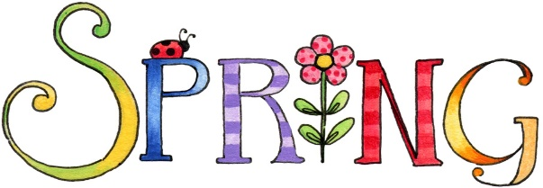May 3, 2019

Partners of WHA Southern District
Greetings!
What a wonderful day was enjoyed by those who attended the Southern District Spring Meeting co-hosted by the Volunteers of Columbus Community Hospital and Edgerton Hospital and Health Services, on Thursday, March 28, 2019. Bruce Kraus, MD, spoke to us about mental health issues and the concerns of accessing care, and also highlighted the concerns of opioid addiction as it relates to mental health. We learned a lot. Check out the Partners of WHA website to see photos from the day.
Our state officers shared information from Partners of WHA with the major emphasis on the bylaws which will be voted upon at our state convention in Appleton in October.
Thank you, Columbus and Edgerton, for a great event.
It was fun to see so many of you at Advocacy Day in Madison on April 17, 2019. Again, there was much information presented for us to take home and share with our hospitals.
Looking forward, please put September 18 on your calendar. Fort Atkinson will be hosting our Fall District meeting and I’m hoping we will have a good showing from all of us in the Southern District. Keep your eyes peeled late summer for registration information.
Another important event in our future is the Partners of WHA State Convention, October 1-3, 2019, at Red Lion Paper Valley, Appleton. I’m hoping we will have a good showing from all the hospitals in the Southern District.
We are still looking for a dedicated person to step forward to accept the position of Public Policy Chair for our District. If you have a willing volunteer in your hospital, please let your District officers know.
I trust you have all gotten your Partners of WHA membership billing for the upcoming year, and will make sure to take care of that as promptly as possible. If you have any questions concerning your bill, don’t hesitate to get in touch with our state treasurer, Julie Steiner, (steinerfam@mwt.net).
Judy Jaggard, Chair; Dianne Schmidt, Chair-elect; Laurie Schmidt, Secretary/Treasurer; Sherry Jelic, CHE

